1. **IMERIT - API KEY**

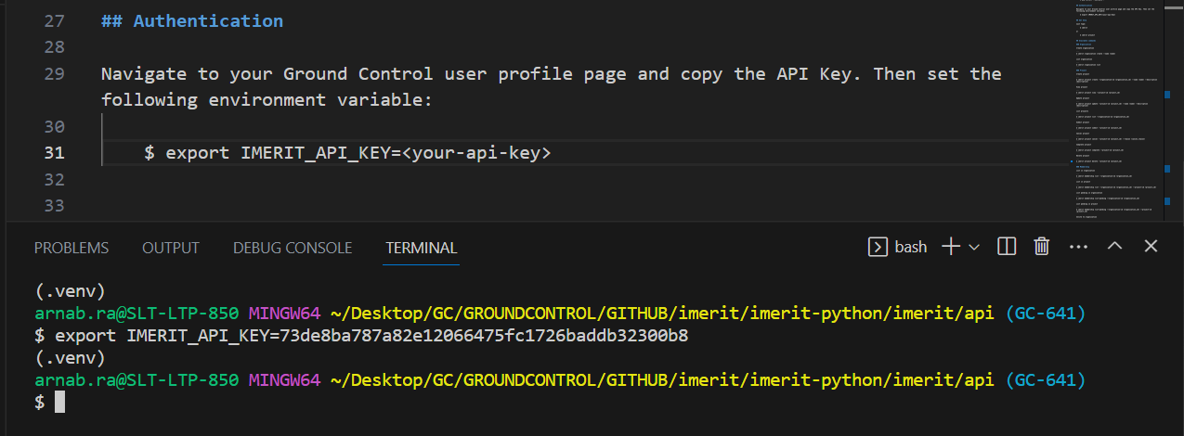

1. **GET HELP**

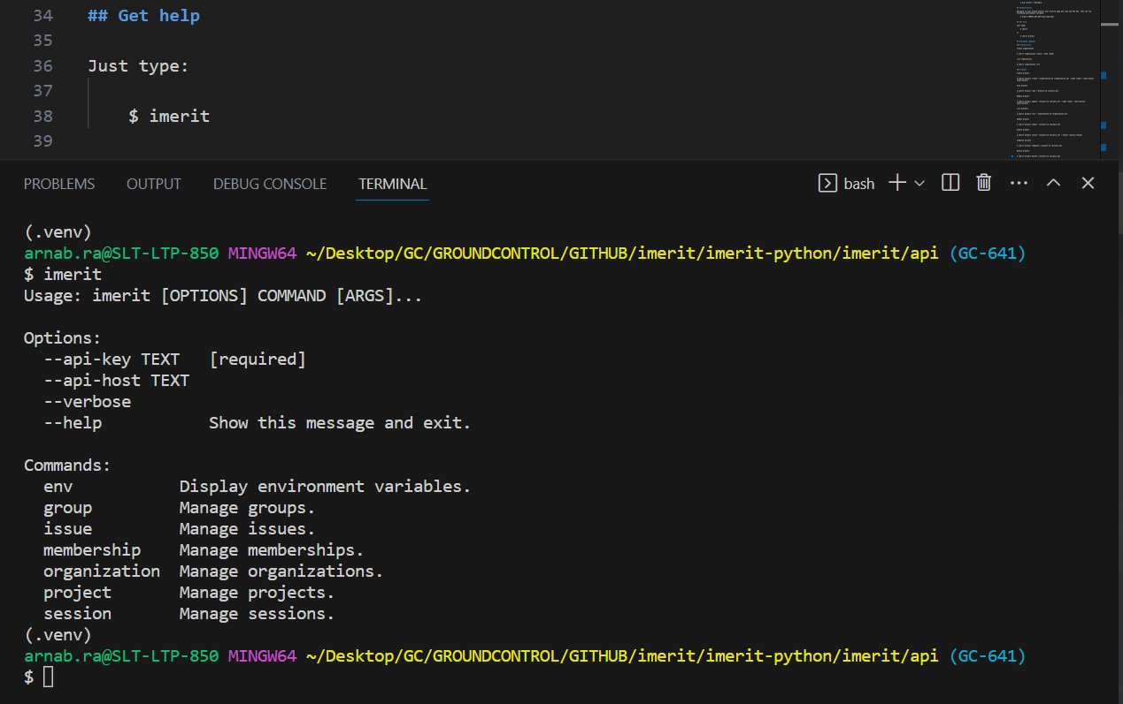

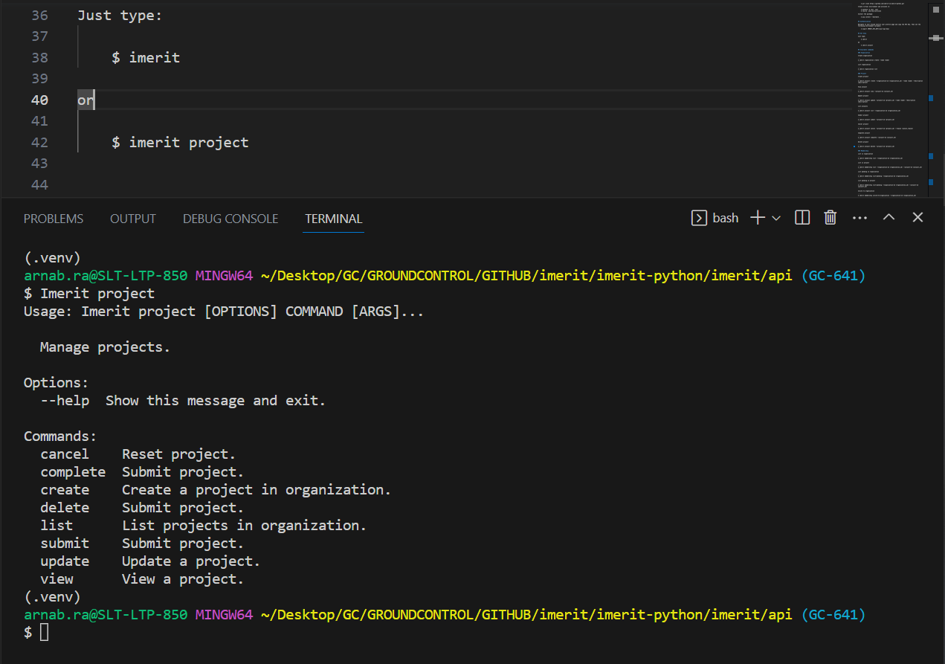

1. **CREATE A NEW ORGANIZATION**

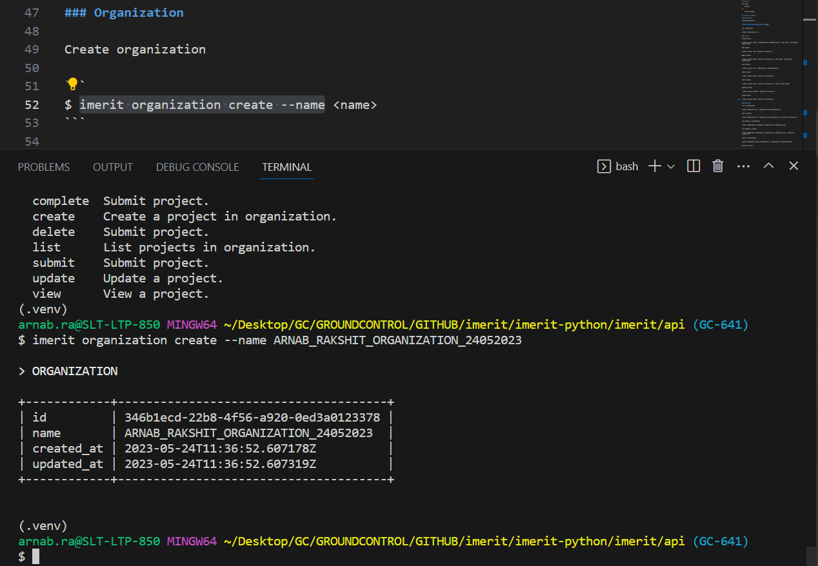

1. **LIST ALL ORGANIZATIONS**

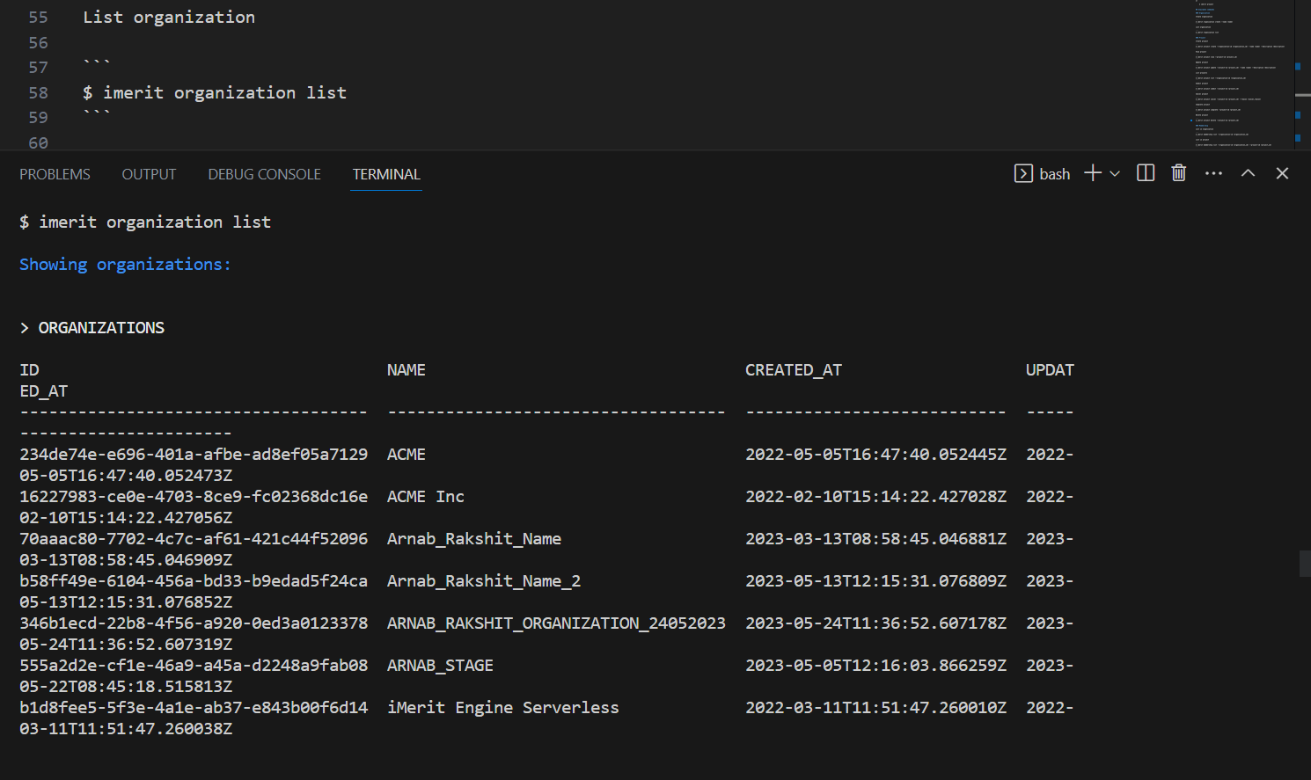

1. **CREATE A NEW PROJECT**

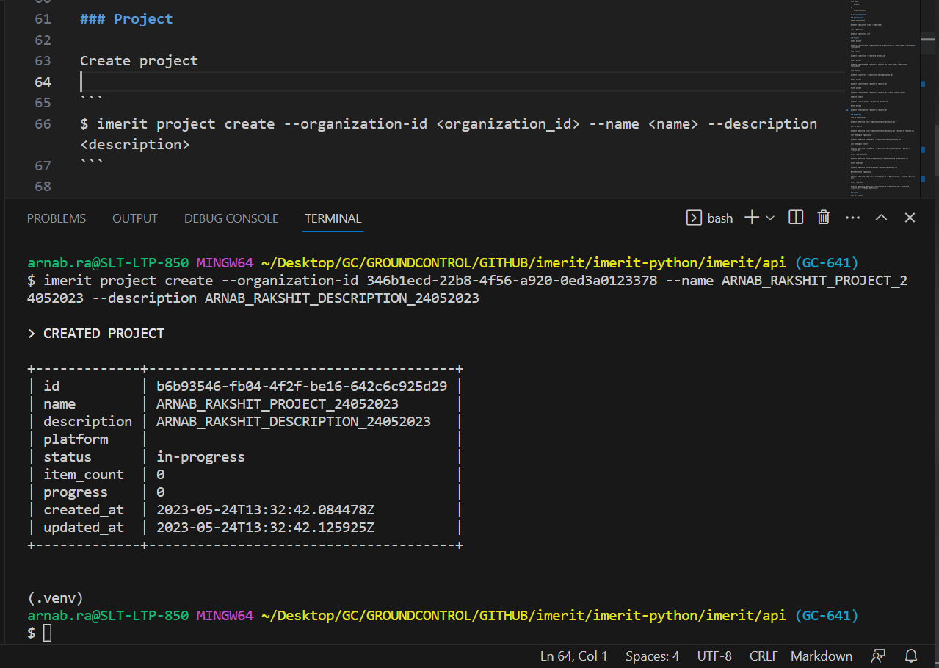

1. **VIEW A PROJECT**

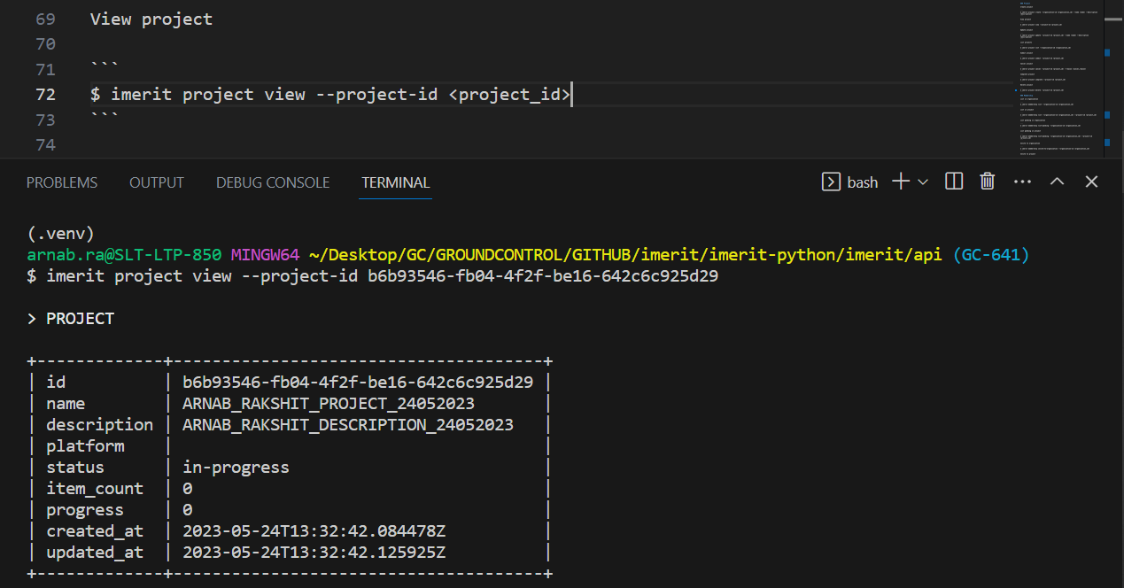

1. **UPDATE A PROJECT**

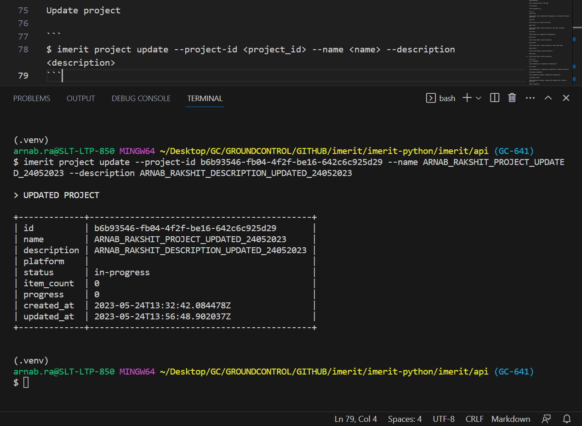

1. **LIST ALL PROJECTS IN AN ORGANIZATION**

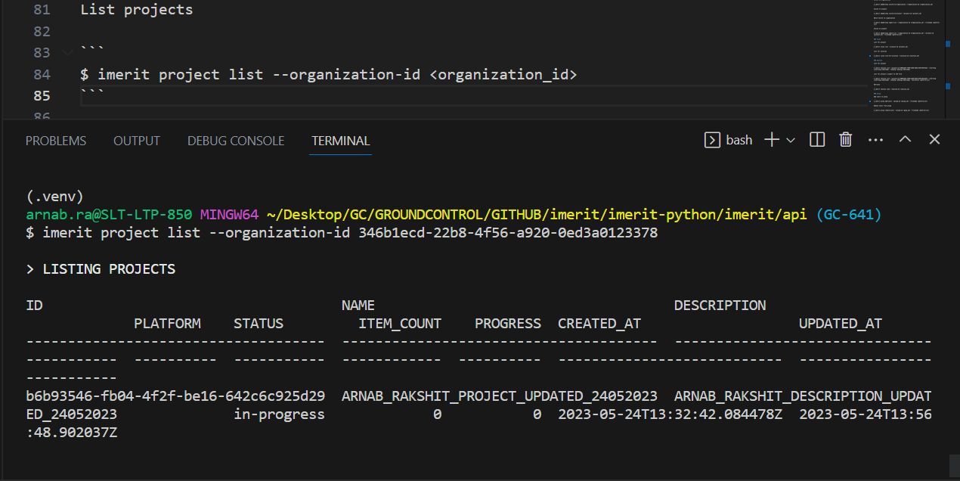

1. **SUBMIT A PROJECT**

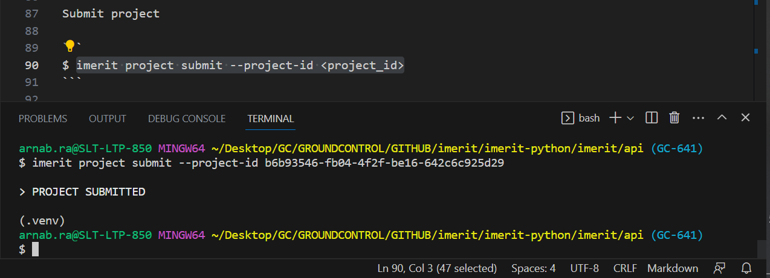

1. **CANCEL A PROJECT**

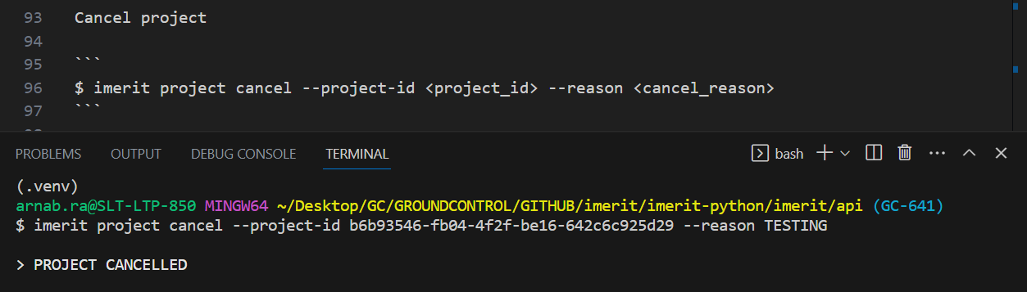

1. **COMPLETE A PROJECT**

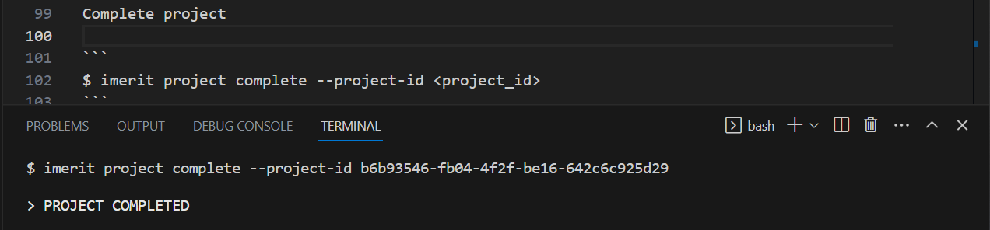

1. **DELETE A PROJECT**

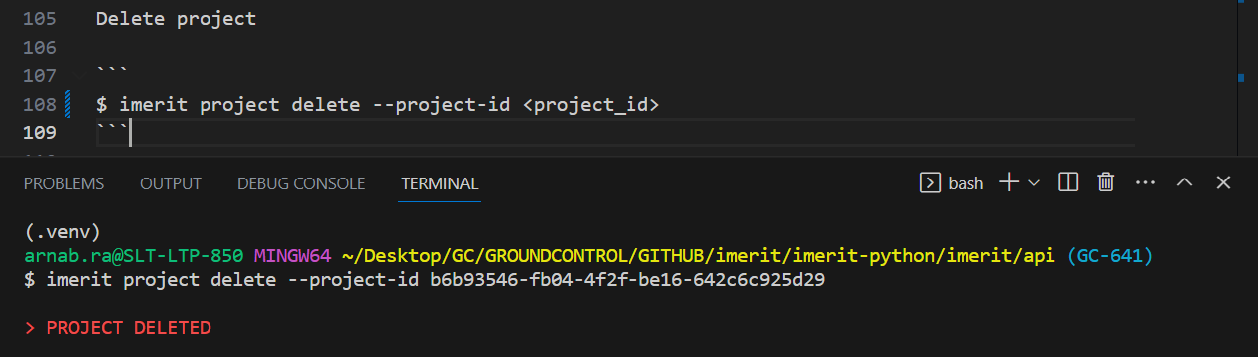

1. **LIST ALL MEMBERSHIPS IN AN ORGANIZATION**

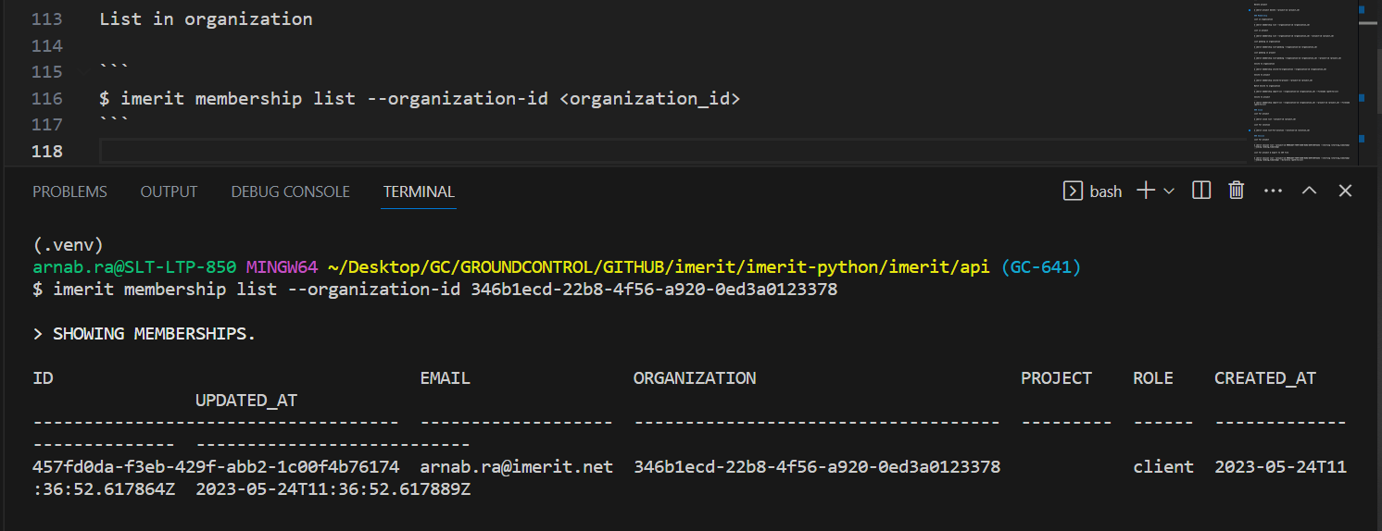

1. **LIST ALL MEMBERSHIPS IN A PROJECT**

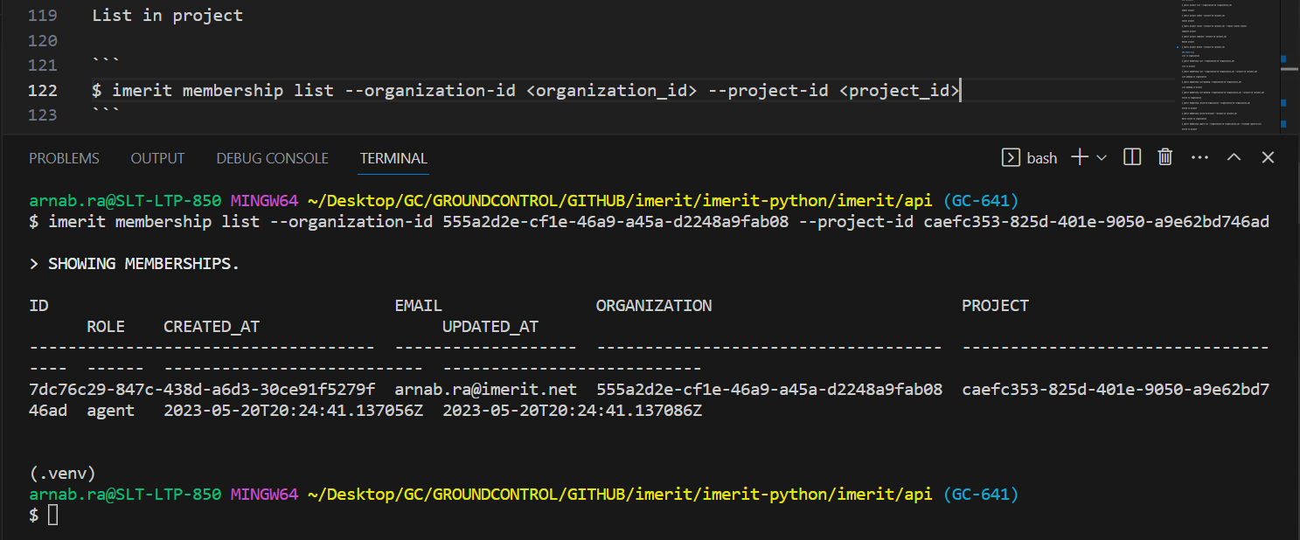

1. **LIST ALL PENDING MEMBERSHIPS IN AN ORGANIZATION**

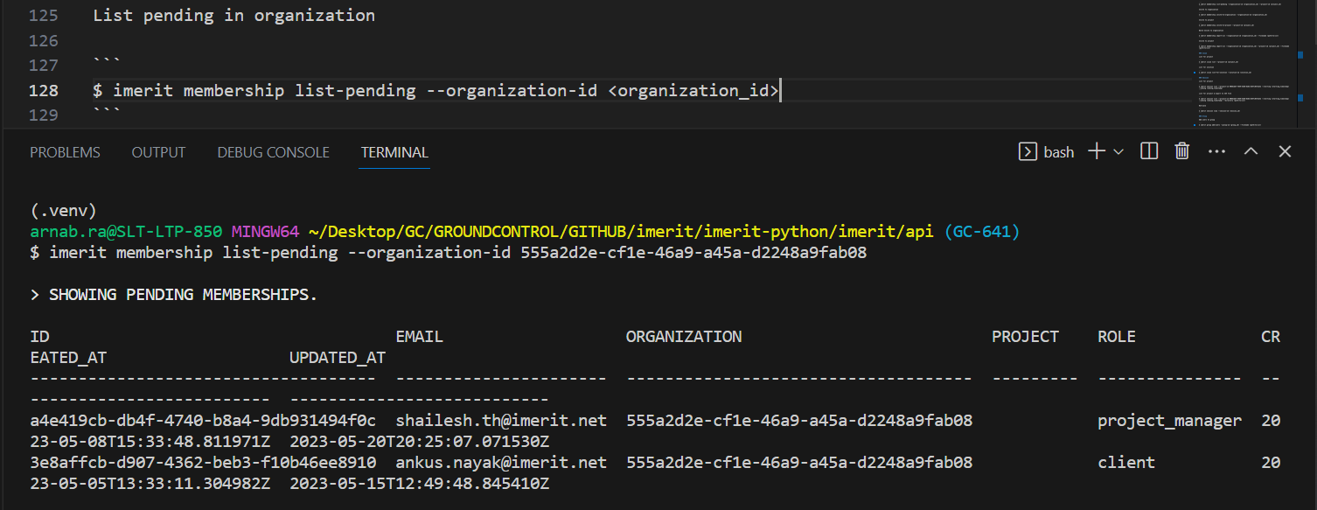

1. **LIST ALL PENDING MEMBERSHIPS IN A PROJECT**

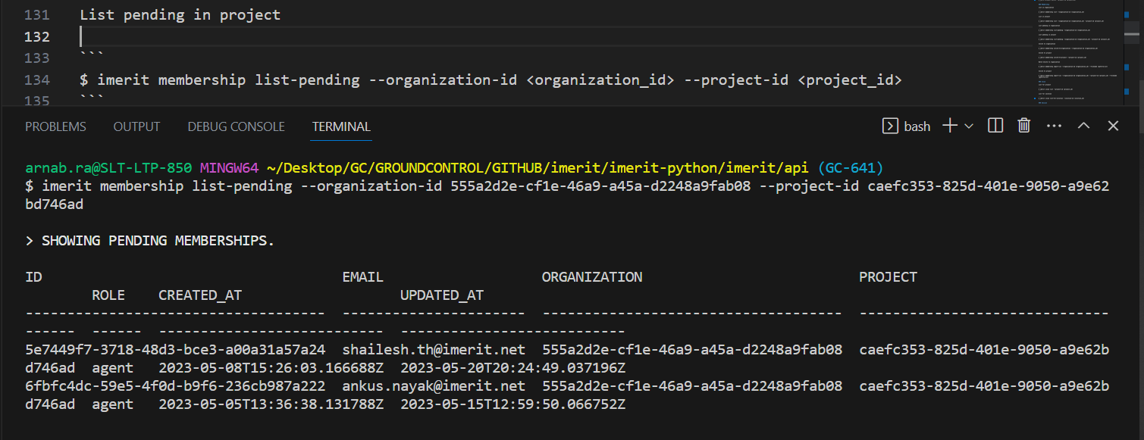

1. **MEMBERSHIP - INVITE TO ORGANIZATION**

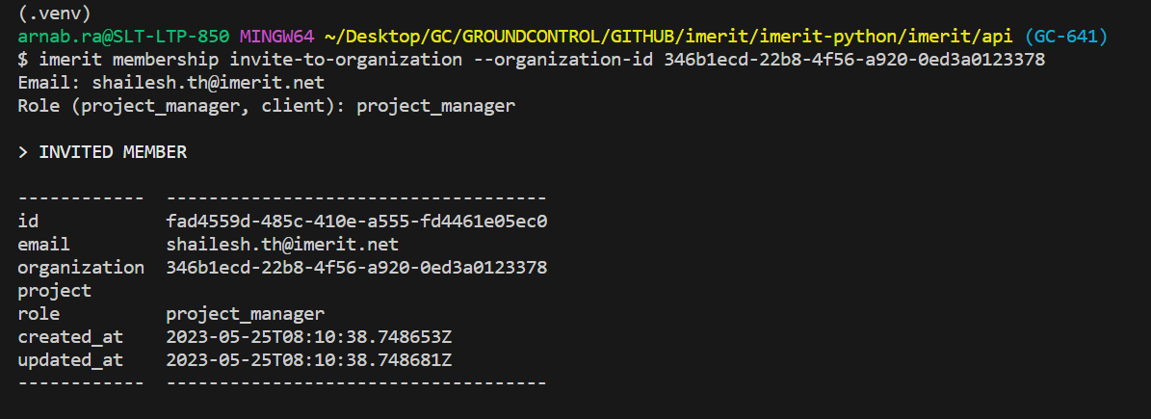

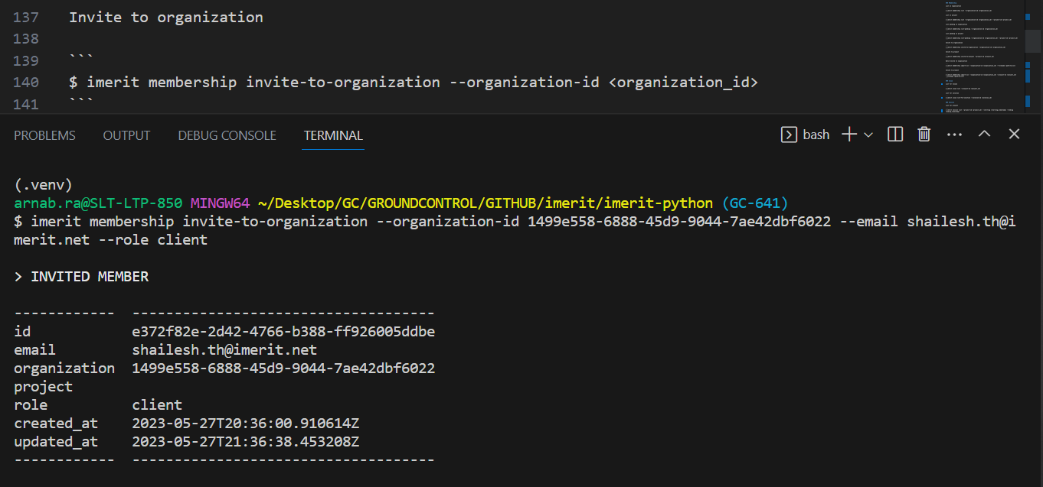

1. **MEMBERSHIP - INVITE TO PROJECT**

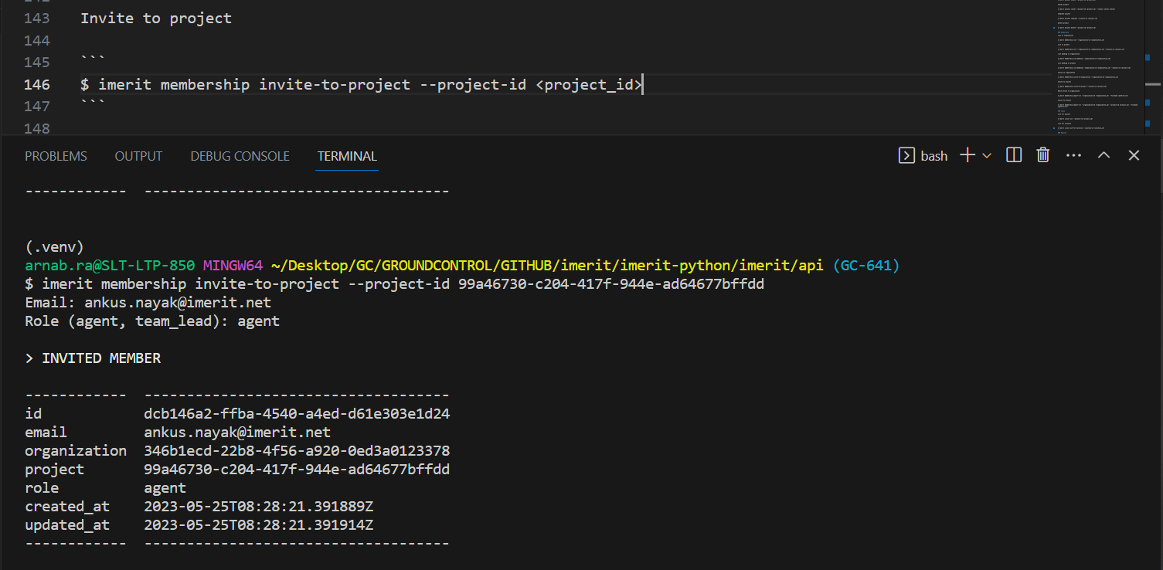

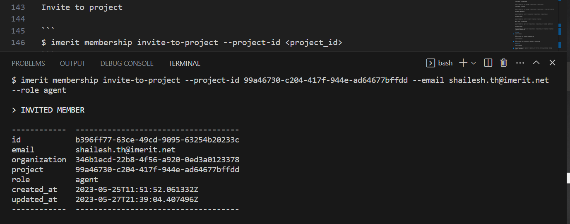

1. **MEMBERSHIP - BATCH INVITE TO ORGANIZATION**

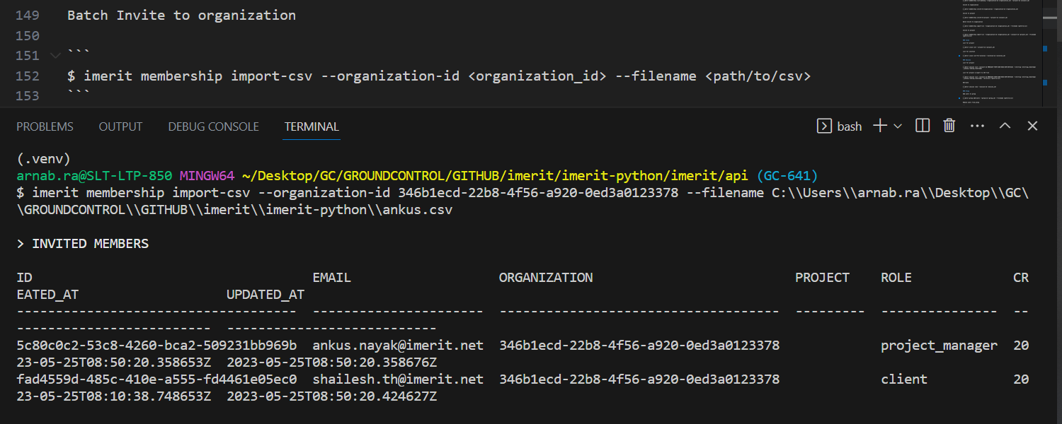

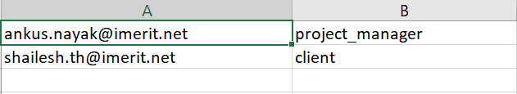

1. **MEMBERSHIP - BATCH INVITE TO PROJECT**

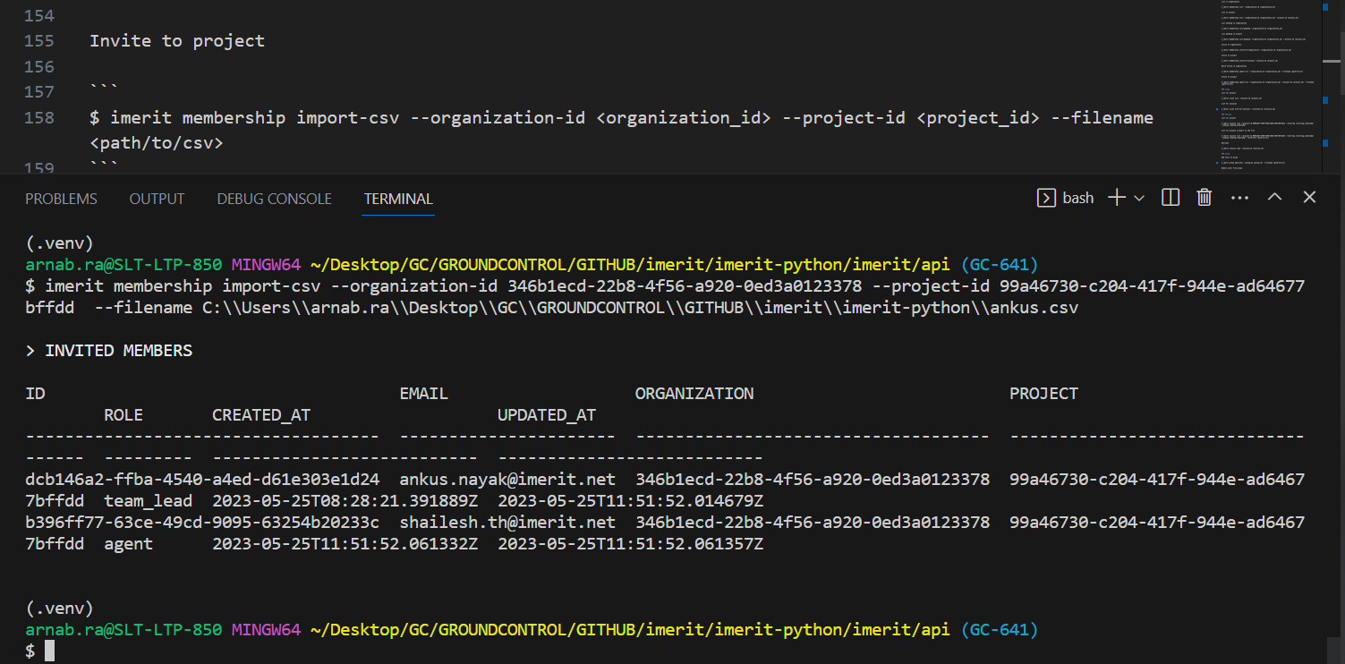

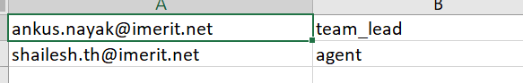

1. **LIST OF ISSUES IN A PROJECT**

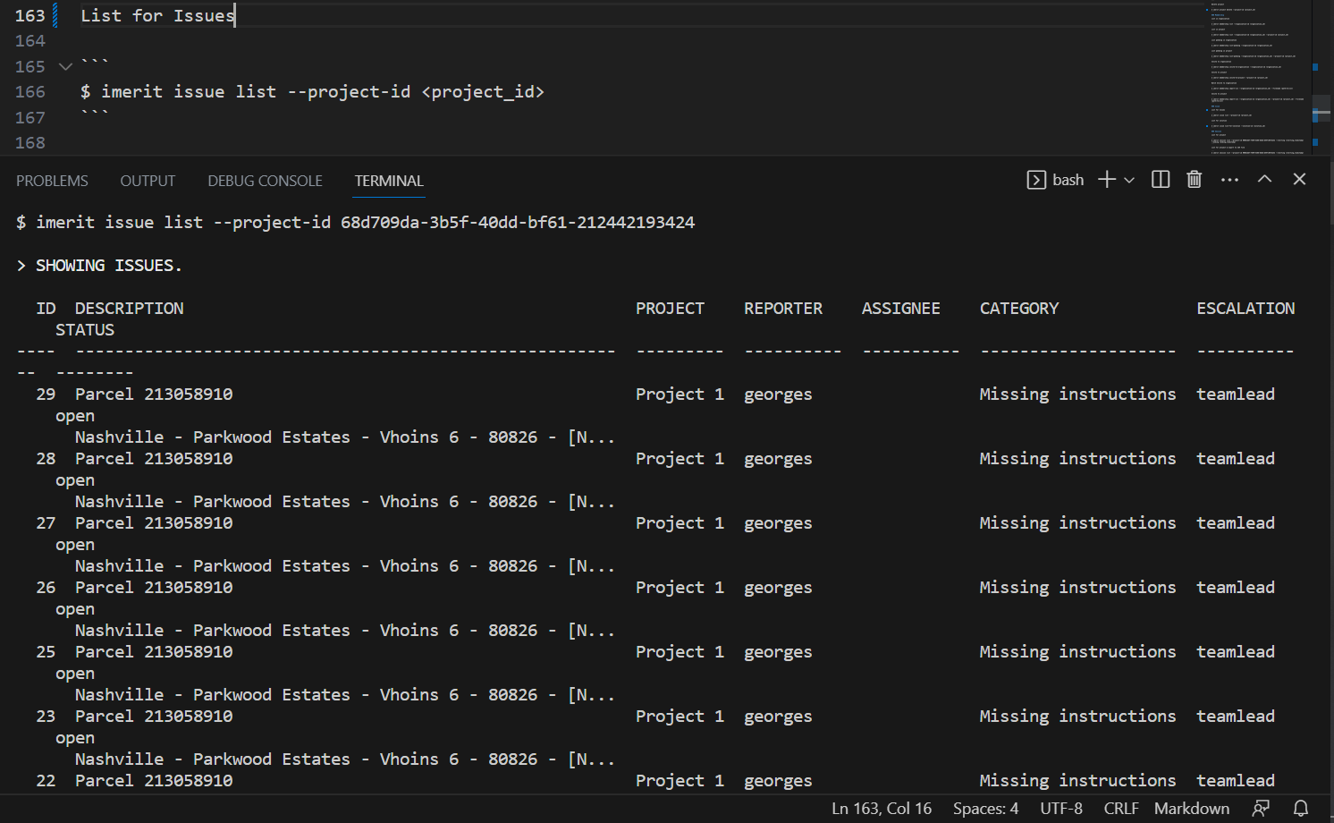

1. **LIST ALL ISSUES LINKED TO A SOLUTION**

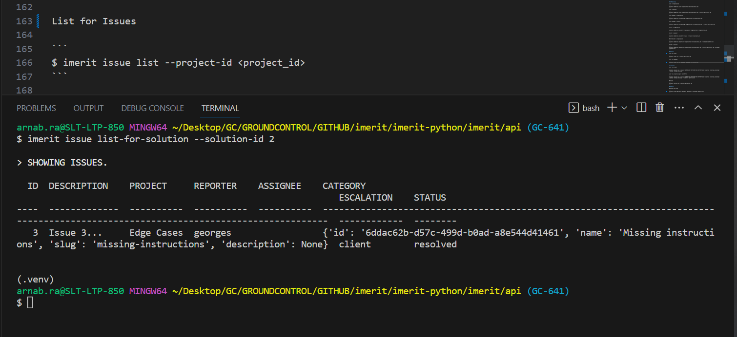

1. **LIST ALL SESSIONS FOR A PROJECT IN A SPECIFIED TIME INTERVAL**

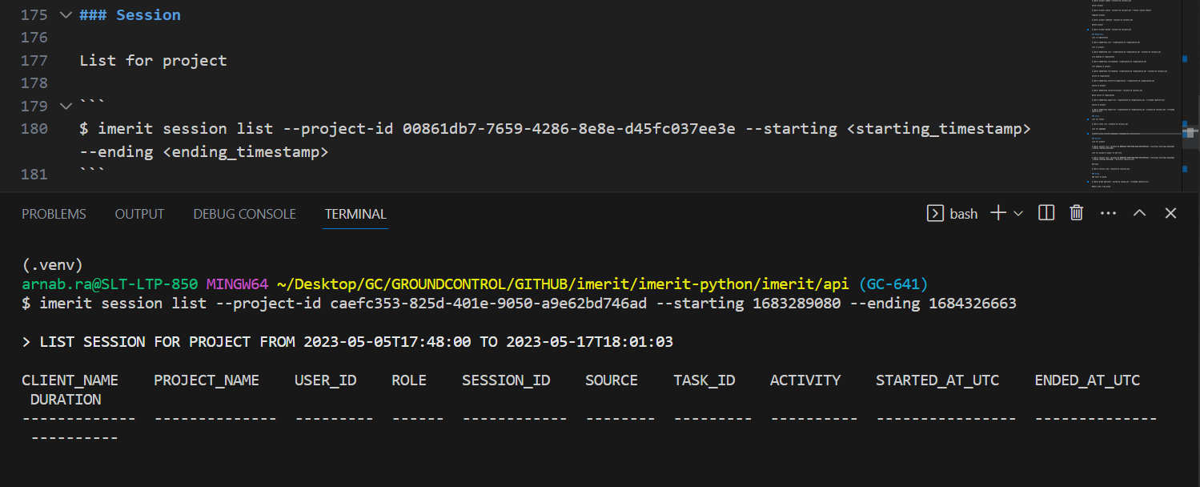

1. **LIST SESSION DETAILS FOR A SPECIFIC SESSION**

